

**GENESIS**

**Five-axis milling drive series**

**Detailed specification configuration**

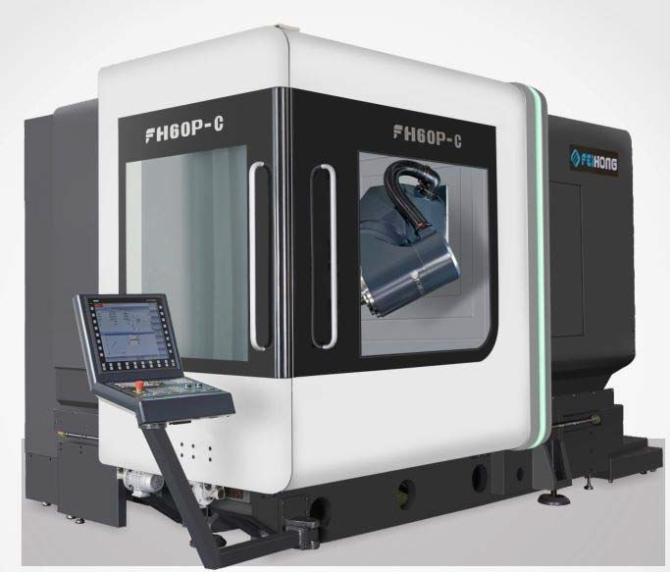

**FH60P‐C**

Five-axis linkage milling and turning compound machining center

XYZ linear shaft hollow cooled lead screw drive

B\C rotary shaft DD direct drive drive Full closed-loop absolute value measurement system

**Guangdong Genesis Intelligent Equipment Co., Ltd**



**1 Scope of supply**

**Standard accessory function sheet**

Standard accessory function sheet（For electronic control, please refer to the controller function）

**GENESIS FH60P-C Five-axis simultaneous mill-turn composite machining center configuration**

1.SIEMENS 840DSL control

2. Genesis five-axis multi-function swing head

3. Electric spindle DGZX-24012/34B2-KFHWVJS

4. HSK-A63 40 tool magazine automatic tool change system

5. X/Y/Z hollow cooling ball screw drive

6. 6 roller linear slides (2 for each X/Y/Z axis)—BOSCH REXROTH

7. X/Y/Z three-axis fully closed-loop optical ruler

8. Electrical box temperature control device

9. Spindle cooler

10. Spiral chip rolling device and rear chip conveyor with chip car

11. Water comes out of the center of the spindle, and the annular spray is water

12. The spindle is blowing in the center and the ring is blowing.

13. The five-axis head crescent blows water, and the crescent blows.

14. Front and side work door safety interlock 1 type each.

15. Spindle circulating cooling device.

16. Waterproof Workday Lights

17. Hydraulic station device

18. Renishaw OMP60 infrared probe device

19. Renishaw laser tool set-up device

20. Centralized automatic feed lubrication device

21. Clean water gun and air connection on the operating side

22. Cutting fluid cooling system

23. Fully enclosed protective sheet metal

24. Operation box

25. The electrical box is equipped with an air conditioner

26. Siemens electronic handwheel

27. Foot-operated spindle loose knife switch

28. Foundation horizontal pads and foundation bolts

29. Tools and toolboxes for adjustments

30. Technical manual

# Basic Specifications



**2**

|  |  |  |  |
| --- | --- | --- | --- |
| **Model** | | **Unit** | **FH60P-C** |
| **Travel** | | | |
| X axis travel | | mm | 600 |
| Y axis travel | | mm | 800 |
| Z axis travel | | mm | 600 |
| Distance from spindle nose to work table surface | | mm | 150-750 |
| Horizontal milling head | | mm | 30-630 |
| Feed/fast moving speed | | m/min | 40 |
| Feed force | | KN | 10 |
| **Rotary table （C axis）** | | | |
| Working table size | mm | | Ø630 |
| Max table load (mill) | kg | | 2000 |
| Max table load (turning) | kg | | 1000 |
| Rotray table | rpm | | 60 |
| Milling/turning woking table  (compound milling and turning) | rpm | | 600 |
| Minimum split angle | ° | | 0.001 |

|  |  |  |  |
| --- | --- | --- | --- |
| **Model** | **Unit** | **FH60P-C** | |
| Rated torque | Nm | 807 | |
| Maximum torque | Nm | 1430 | |
| **CNC swing milling head（B axis）** | | |
| Swing range(0=Vertical/180=Level) | ° | -15～180 | |
| Fast moving and feeding speed | rpm | 80 | |
| Minimum split angle | ° | 0.001 | |
| Rated torque | Nm | 743 | |
| Maximum torque | Nm | 1320 | |
| **Spindle （Milling）** | | |
| Spindle speed | rpm | 12000 | |
| Spindle power(S1/S6) | Kw | 34/42 | |
| Spindle torque(S1/S6) | Nm | 132/185 | |
| Spindle taper |  | HSKA63 | |
| Distance from spindle center to beam guideway surface | mm | 1064.5 | |

|  |  |  |
| --- | --- | --- |
| **Model** | **Unit** | **FH60P-C** |
| **Tool magazine** | | |
| Tool interface |  | HSKA63 |
| Tool magazine capacity | PCS | 40 |
| Max tool diameter/length/weight |  | Ø85/300/8 |
| Tool switch(Tool to) | S | 1.8 |
| **Measuring device** | | |
| Infrared probe | Rensishaw OMP60 | |
| Tool detection instrument in  working processing area |  | Rensishaw  NC4F230 |
| **Processing capacity** | | |
| Max drilling diameter(Medium steel) |  | Ø40 |
| Max tapping diameter(Medium steel) |  | M24 |
| Max milling diameter(Medium steel) |  | 250 |
| **Position accuracy(ISO230-2 and VDI3441)** | | |
| X/Y/Z positioning accuracy | mm | 0.005 |
| X/Y/Z Repeat positioning accuracy | mm | 0.004 |
| B/C positioning accuracy |  | 8" |
| B/C Repeat positioning accuracy |  | 4" |

|  |  |  |
| --- | --- | --- |
| **Model** | **Unit** | **FH60P-C** |
| **Controller** | | |
| Control system |  | Siemens840D |
| **Others** | | |
| ） Machine height(General machine) | mm | 2985 |
| Occupied area for main machine(L*W) | mm | 4300x2600 |
| Occupied area for tool magazine(L*W) | mm | 2100x1250 |
| Occupied area for chip conveyor(L*W) | mm | 3070x1065 |
| Occupied area for water tank(L*W) | mm | 1785x1355 |
| Grand total occupied area to complete  machine(L*W) | mm | 5200x3550 |
| Machine weight | Kg | 15000 |



Appearance dimension drawing FH60P-C

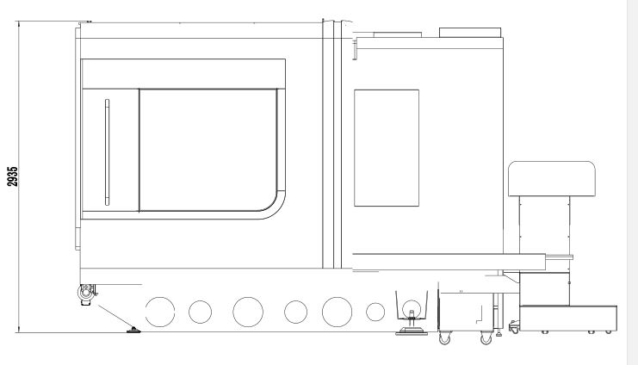

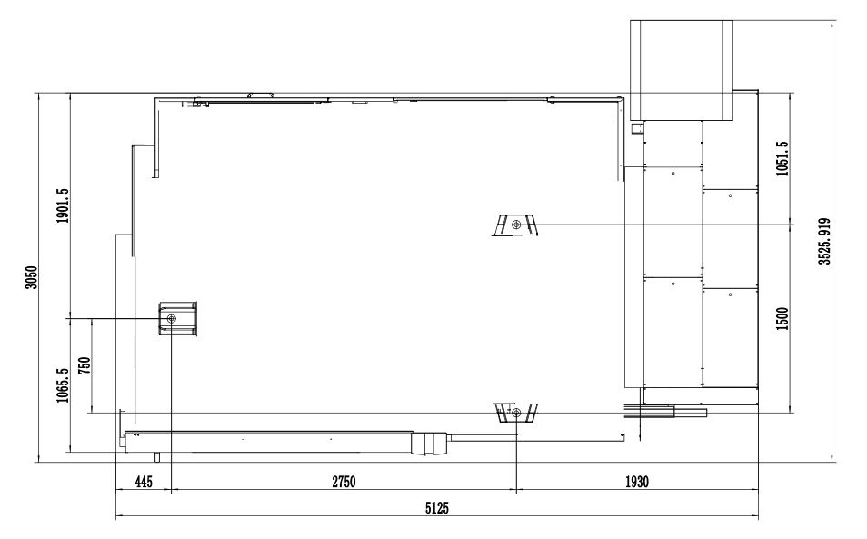



**3 CNC system**

）

|  |  |  |  |
| --- | --- | --- | --- |
| Control system | Siemens 840DSL(Motor and drive) | | |
| Number of control axes | 5-axis simultaneous milling with simultaneous turning (NC axis + spindle, BC axis) | | |
| Simultaneously controlled axes 5-axis linkage milling with turning | Positioning axis | Standard X、Y、Z、B、C | |
| Interpolation | straight line | X、Y、Z、B、C axis（X、Y、Z、B、C available for compensation |
| Arc | X、Y、Z、B、C axis（X、Y、Z、B、C available for compensation |
| Minimum instruction unit | 0.001um | | |
| Minimum control unit | 0.1nm | | |
| Display | 19LCD | | |
| Motor | Triple overload capability with absolute encoder (encoder position is never lost) | | |
| External communication function | Ethernet and RS232C interface | | |
| Operation mode | MDI、Automatic、Manual、Handwheel、Back to origin (absolute)、REPOS | | |
| Programming | Online ISO language editor | | |
| Maximum PLC programming storage capacity | 2048KB | | |
| Interpolation function | Straight line, circle through center point and center point, helix, refined surface, high speed setting, etc. | | |
| Tool compensation amount | 512 groups | | |
| 手轮倍率 | 0.1/0.01/0.001mm | | |
| 最小设定和移动单位 | 1um/X,Y,Z | | |
| 数据保存 | 内存数据掉电永不丢失 | | |
| 进给倍率 | 0%-150% | | |
| 快进倍率 | 0%-100% | | |
| 输入输出接口 | 以太网及 RS232C 接口、CF 卡、USB 存储备份 | | |
| 显示语言 | 中、英 | | |

）



**4 Standard configuration quantity**

|  |  |  |  |
| --- | --- | --- | --- |
| No. | Parts name | Unit | Quantity |
| 1 | Foot control switch | Set | 1 |
| 2 | Hydraulic clamping mechanism | Set | 1 |
| 3 | Centralized lubrication device | Set | 1 |
| 4 | Cooling system | Set | 1 |
| 5 | Working lamp | Set | 1 |
| 6 | Three-color light | Set | 1 |
| 7 | Horizontal bridge | Pcs | 1 |
| 8 | Machine Tool Fixtures | Set | 1 |
| 9 | Standard Knife Package | Set | 1 |
| 10 | Security door lock | Set | 1 |
| 11 | Foundation kit | Set | 1 |
| 12 | Installation adjustment tool | Set | 1 |
| 13 | Rigid tapping and spindle multi-point positioning | Set | 1 |
| 14 | Spiral chip conveyor and chip automatic chip removal machine | Set | 1 |
| 15 | Standard hydraulic system | Set | 1 |

# Main outsourcing parts configuration table



**5**

|  |  |  |  |
| --- | --- | --- | --- |
| Main parts name | Origin | Brand | Remark |
| Control system | Germany | Siemens | Siemens 840DSL |
| Spindle motor | China | HAOZHI |  |
| X、Y、Z servo motor | Germany | Siemens |  |
| Spindle | Joint venture | FEIHONG | Adopt German FAG bearings |
| Spindle bearing | Germany | FAG |  |
| Screw bearing | Germany | FAG |  |
| Linear Guides | Germany | Rexroth | UP grade accuracy |
| Ball screw | Taiwan | HIWIN | C3 grinding grade |
| Hydraulic Components | China | FEIHONG |  |
| Automatic lubrication system | China | BAOTN |  |
| Cooling system | China | FEIHONG |  |
| Lighting system | China | ONN |  |
| Warning light | China | ONN |  |
| Electric | France/Germany | Schneider /Siemens |  |
| Drag chain protection | China | JUNHONG |  |
| Control wire and cable | Germany | Lap Nanni |  |

# Brief description



**6**

**Main Machine Specification| Optimum Rigid Structural Configuration**

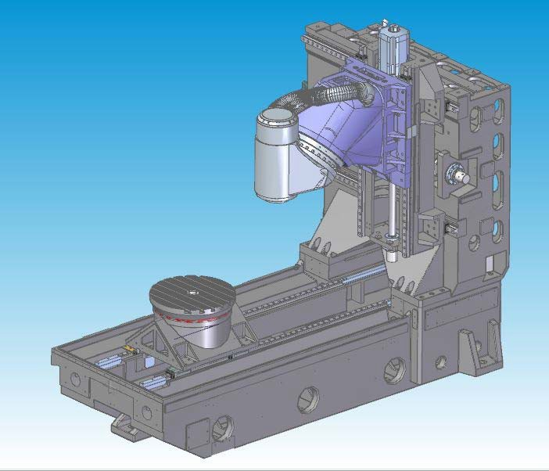

**Design features|** Optimal analytical design of mechanical wire castings

  Full-box thermal symmetry cast construction, made of Meehanite high-grade cast iron

  Tempering plus natural aging treatment to eliminate internal stress

  Structural natural frequency vibration eliminates material processing stress

  The design of high-rigidity column with large area of full wall effectively improves rigidity, static and dynamic accuracy

  Three-axis hollow cooled lead screw drive

## CNC swing milling head (B axis)

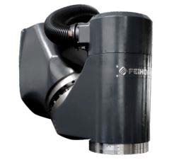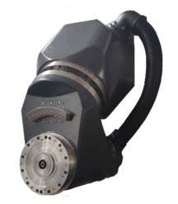

**Design features**

  Built-in DD motor zero drive chain no backlash design

  High acceleration characteristics.

  The shortest spindle tool tip point and structural support point span to achieve maximum cutting rigidity

  Larger YRT bearings increase rigidity

  Equipped with HEIDENHAIN RCN8380 series absolute rotary encoder measuring system, fully closed-loop control ensures the best accuracy.

  Spindle、B axis cooling system design to reduce heat transfer.

## Rotary table (C axis)

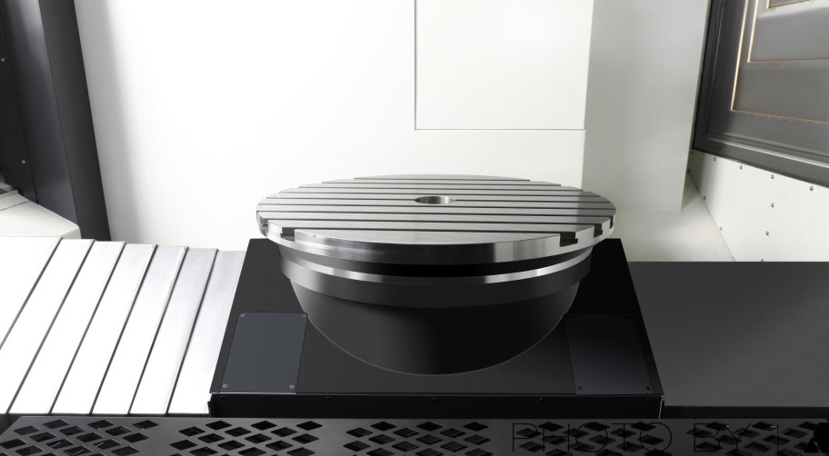

**Design features**

  Built-in DD motor zero drive chain no backlash design.

  High acceleration characteristics.

  Larger YRT bearings increase rigidity.

  Large rated driving torque, positioning processing with table positioning clamping device.

  Meet the needs of milling, reduce the handling of work pieces, and improve product accuracy

  Equipped with HEIDENHAIN's high-precision rotary encoder measuring system, fully closed-loop control ensures optimum accuracy

  Cooling system design to reduce heat transfer.

## Liftable tool setting instrument

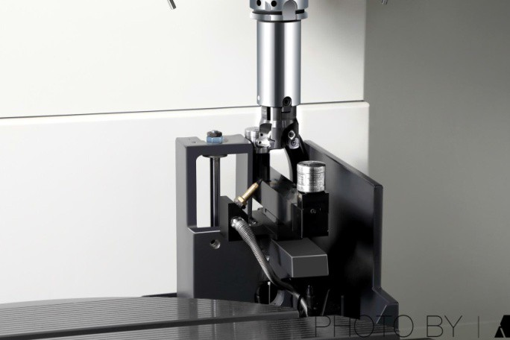

**Design features**

  Equipped with Ransishaw NC4F230R tool setter for higher precision. 

 Automatic tool setting on machine, tool compensation automatic update

  The tool setting device can be lifted to save the space of the processing surface

  Fully sealed sheet metal design protects the tool setter from water and iron filings during processing.

## Infrared probe

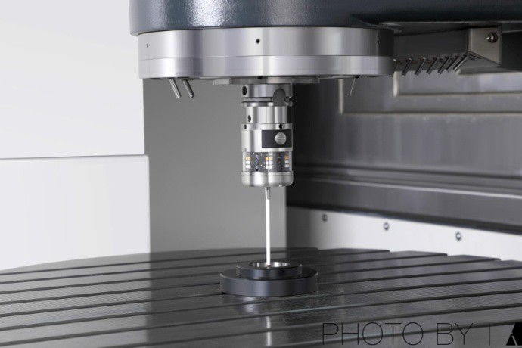

**Design features**

* Equipped with Ransishaw OMP60 trigger optical probe.

  In the machine workpiece alignment and dimensional inspection, reduce manual inspection errors, improve product accuracy and processing efficiency

  Save 90% of on-machine assistance time

## Safety guard sheet metal

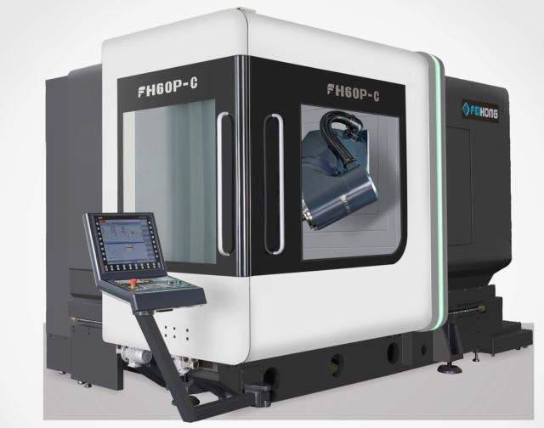

**Exterior**

The FH series five-axis mill-turn composite machining center cover is designed to comply with strict CE safety standards, with a full-density sheet metal to prevent the operator from entering the working range during processing, and to prevent the use of high-pressure cutting fluid or chips sprayed out of the machine. And has a large peeping window, convenient for the operator to understand the operation and processing of the machine.

**Clean** Use telescopic guards and protective sheet metal to protect chips generated during operation to avoid cutting splashes and damage to other mechanisms

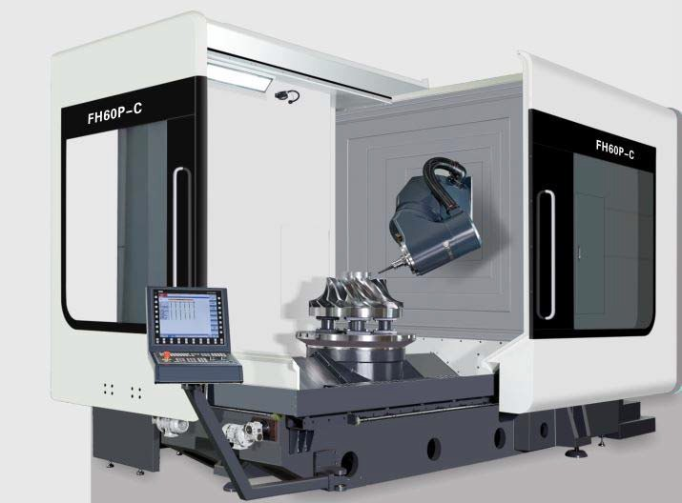

## Lighting

The working area is equipped with two LED lights, and the illumination is maintained above 800LUX, providing the operator with a suitable bright working environment.

**Operability** The operation side is equipped with a split sliding door to provide a large opening space, which is convenient for the workpiece to be freely loaded and unloaded from three directions using the overhead crane.

**Technical information**



**7**

1、Operation Manual（Including electrical operation manual, electrical schematic diagram, electrical alarm code, etc.）one copy

2、Maintenance Manual(one copy)

3、Repair Manual (one copy)

4、Parameter specification (one copy)

5、Machine certificate (one copy)

6、Machine parameter backup (one copy)



**8 Environmental standards and related requirements for the installation and use of machine**

1、Environmental parameters

|  |  |  |
| --- | --- | --- |
| Item | Environmental parameters condition | Remark |
| Temperature | 17℃～25℃（Working) | Allowable range: 15 °C ~ 40 °C, ideal operating environment± 2 °C |
| 0℃～60℃（Transportation) |
| Humidity | 20℃时 40%～70% | No condensation |
| Vibration | 0.5G below |  |

2、Installation site

  The device must not be installed in radiation, such as microwave, ultraviolet, laser, or X-ray ranges.

  In order to ensure the machining accuracy of the machine tool and reduce the temperature difference around the equipment, please do not install in the following areas:

a）Direct sunlight b）High humidity c）Large temperature difference d）Vibration e）Strong magnetic field f）Dusty

  Avoid the following situations around the installation area of the device:

a）Garage



b）There are lanes where cars come and go

c）Pressure or stamping equipment

d）Electric, spot or hydrogen arc welding

e）Substation

f）High voltage line

g）Equipment or processing that is prone to dust generation

3、Installation site requirements

  The foundation of the equipment installation site must be fully compacted. There are no undesirable phenomena such as cavities and virtual soil.

  The equipment installation site must have a fixed power supply that meets the relevant requirements of the state, and no temporary power supply must be used, and the equipment must be guaranteed to have good grounding protection.

  The installation site of the equipment must have a stable air source, and the compressed air provided must be dry, clean compressed air that meets the relevant national requirements.

4、Installation site requirements

  Power interface: the power supply provided by the equipment installation site must be three-phase four-wire system, the power line voltage is 380V, pay attention to the stability of the power supply, and ensure that the power supply voltage fluctuation should not be higher than ±5%. If the equipment site provides a three-phase four-wire power line with a voltage of 220V±5%. When the equipment is connected to the power supply, it should no longer be connected through the transformer.

  Compressed air interface: p=4~6kgf/cm², Q=5m³/h, reserved ¢10 quick connector, joint knife equipment installation position, reserved ¢10~m for temporary adjustment on site. The main circuit of compressed air must be equipped with a main pipeline filter and dryer. The air pressure must be guaranteed at 0.5~0.7Mpa.

5、Party A reserves enough installation space according to the appearance size of the machine tool of the equipment sample provided by Party B to facilitate the positioning and maintenance of the machine tool.

6、Party B is responsible for the installation and commissioning of the equipment free of charge, and Party A is responsible for the placement of the equipment at the installation site.

# Acceptance



**9**

  Party A shall carry out the acceptance of the technical performance of the equipment: a）Visual inspection

b）Mechanical body standard specification acceptance

c）24 hours operation without load

  Party A checks and accepts according to the above configuration list

  Party A shall carry out the acceptance of technical data

# Technical support and after-sales service



**10**

Party B makes the following service commitments to Party A

1. The complete machine is guaranteed free of charge for 12 months.（Except for abnormal use）

2. Cost price supply of wearing parts, spare parts, spare parts（Out of warranty）；

3. Party B provides Party A with processing technology and processing programming consulting services;

4. If Party A's equipment fails, Party B shall respond within 4 hours and call Party A to guide Party A to eliminate the fault. If Party A cannot be excluded, Party B will arrive at Party A's site within 48 hours;

5. After the expiration of the shelf life, Party B still provides after-sales service;

6. If the user moves the device within two years, the user shall bear the shipping fee, and Party B will guide the installation and debugging free of charge;

7. Regular usage tracking service, irregular user follow-up.



**11 Others**

1. This agreement is in two copies, one for each of A and B

2. The annex to this contract is a valid part of the contract and has the same legal effect as the original contract.

**Matters not mentioned above shall be resolved through friendly consultations between the two parties.**

Representative of A（Stamp）： Representative of B（Stamp）：

Representative of A Sign： Representative of B Sign：

Date of signature： Date of signature：